The Secretary,
Board of Technical Education,
Jammu and Kashmir.

No: KGP/Estt/2025/548-549 Dated: 10-07-2025

Subject: Request for Replacement of Examination Duty for Center No. MJ25-099.
Sir,
With reference to your office order no 32 of 2025, dated 01-07-2025 issued vide endorsement no BOTE/Exam/MJ25/2632-2650, dated:01-07-2025 for the 4th semester examination duties, I kindly request for the replacement of Mr. Mohd Amin Wani, Lecturer-I, KGP Srinagar with Ms. Baiza Rafiqi, Foreman, GPC Ganderbal for the examination center no. MJ25-099(Government Polytechnic College Ganderbal).Kindly consider this request and update the duty roster accordingly.

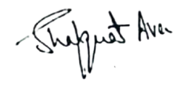
Yours Faithfully

Principal
Kashmir Government Polytechnic College
Srinagar

Copy to the:
1.Principal,Government Polytechnic College Ganderbal for information.

